Set 4: Product Inventory Management
1.Create the Dataset Bar Graph
Code:
product <- data.frame(
ProductID = c(1,2,3,4,5),
ProductName = c("Product A","Product B","Product C","Product D","Product E"),
Quantity = c(250,175,300,200,220)
)
Product
barplot(product$Quantity,
names.arg = product$ProductName,
col = "skyblue",
xlab = "Product Name",
ylab = "Quantity Available",
main = "Product Inventory")
Output:
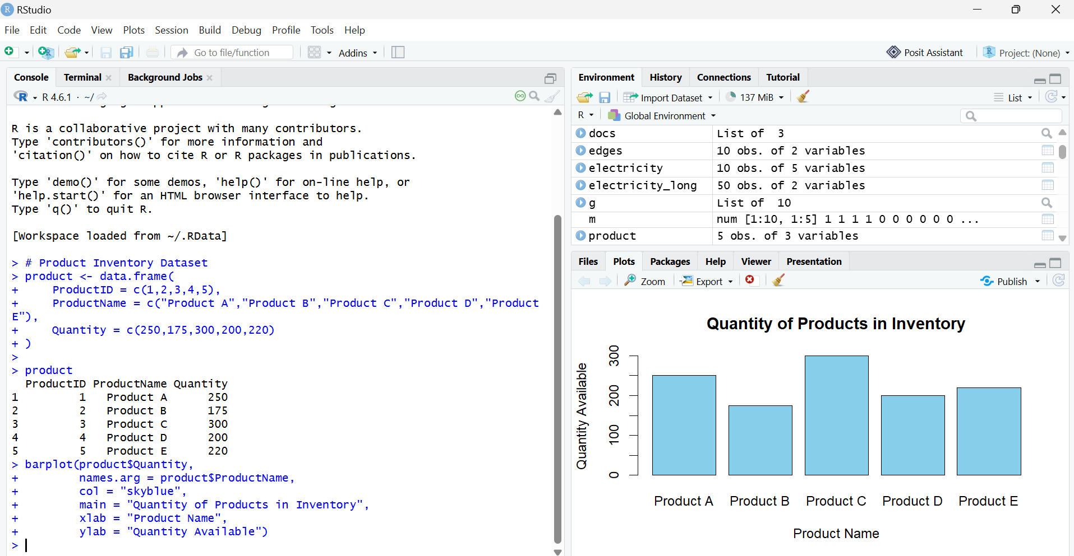

2. Stacked Bar Chart
Code:
product$Category <- c("Electronics","Electronics",
"Furniture","Furniture","Clothing")
qty <- matrix(product$Quantity, nrow = 1)
colnames(qty) <- product$ProductName
barplot(qty,
col = c("red","blue","green","orange","purple"),
main = "Stacked Bar Chart of Product Categories",
xlab = "Categories",
ylab = "Quantity",
legend.text = product$ProductName)
Output:
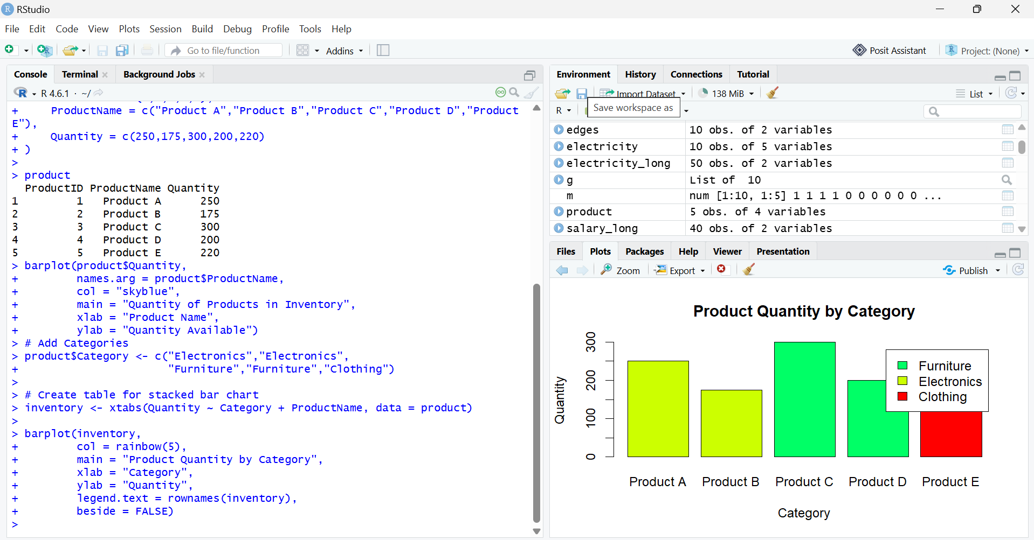

3. Scatter Plot (Price vs Quantity)
Code:
product$Price <- c(500,700,400,650,550)
plot(product$Price,
product$Quantity,
pch = 19,
col = "blue",
main = "Product Price vs Quantity",
xlab = "Product Price",
ylab = "Quantity Available")
text(product$Price,
product$Quantity,
labels = product$ProductName,
pos = 3)
Output:
